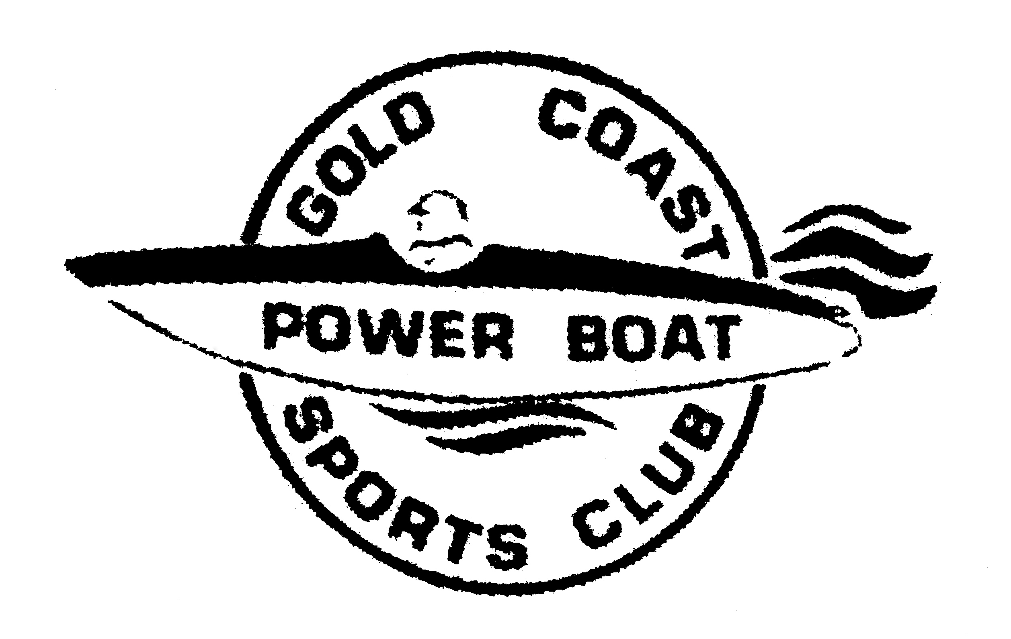
GOLD COAST POWER BOAT & SPORTS CLUB

P.O. BOX 101
CORINDA QLD 4075
CRAIG LEWIS
Commodore

Membership Renewal
2014 / 2015

Name:..............................................................................................

Address:................................................................................................................................................................................

..............................................................................................................................................................................................

Postcode:........................

Telephone: Home:.................................................

Mobile:...............................................

Email Address: ........................................................................................................................

APBA No (if applicable):..............................................

(Please Tick One Only)

Race Membership $50.00 ----------------

Club Membership $25.00 ----------------

Family Membership (includes juniors) $50.00 ------------------

Please see enclosed cheque/money order for $-----------------------

Cheques are made payable to Gold Coast Power Boat and Sports Club. Please send to the above address or pay via direct deposit (see details below). If paying by direct debit, can you please ensure you use your surname and/or boat name in the reference section.

Direct Deposit
A/C Name: Gold Coast Power Boat and Sports Club
NATIONAL AUSTRALIA BANK
BSB: 084 771
Account Number: 153153390
ABN 48 152 179

